

**(DAY** **-NULM)**

**National Urban Livelihood Mission**

**Course: Accounts Assistant Using Tally**

Sayajigunj Center- Batch No: TN2438980153

**Examination**

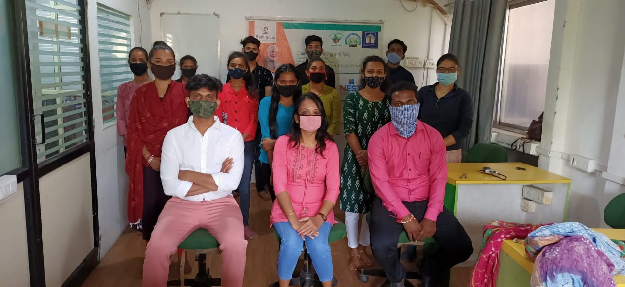

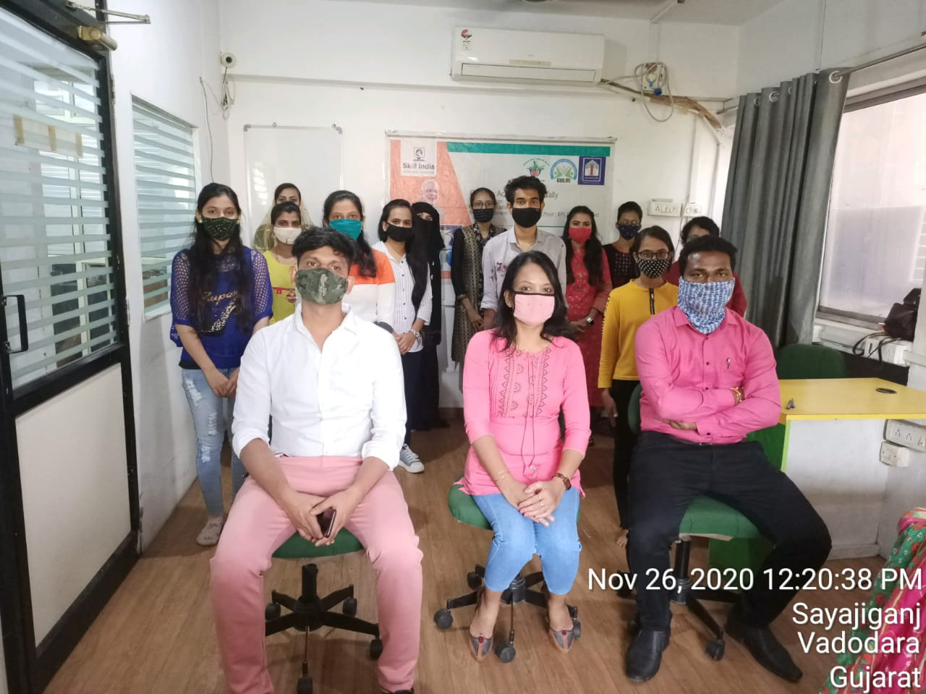

**NIDAN TECHNOLOGY PVT LTD**



**(DAY** **-NULM)**

**National Urban Livelihood Mission**

**Course: Accounts Assistant Using Tally**

Sayajigunj Center- Batch No: TN2438980153

**Theory Examination**

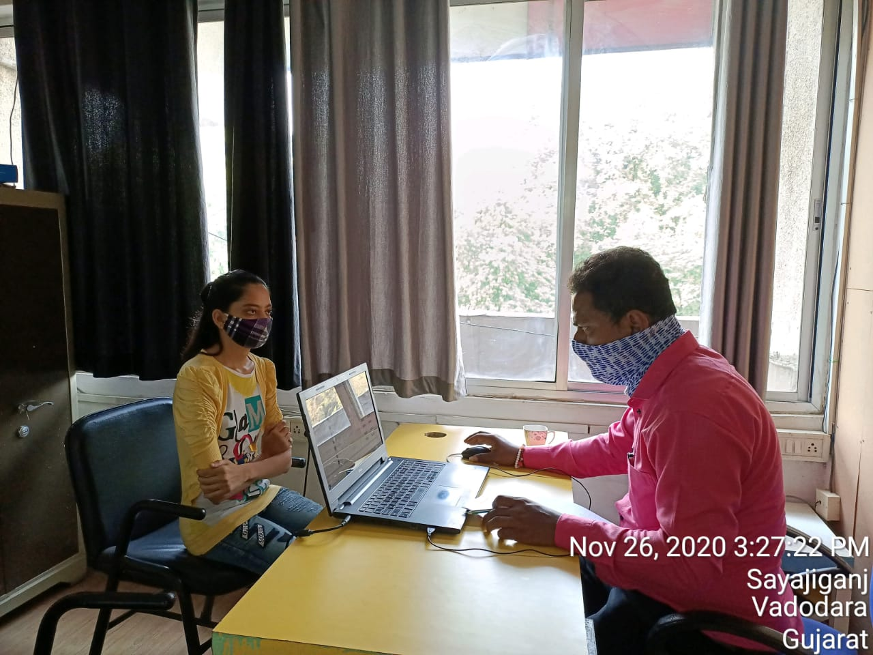

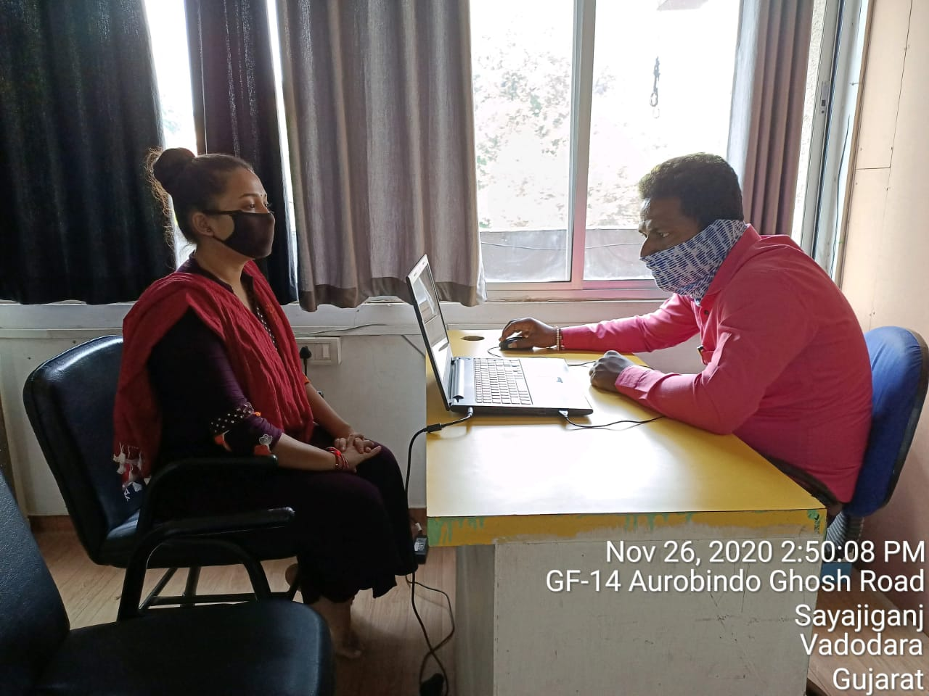 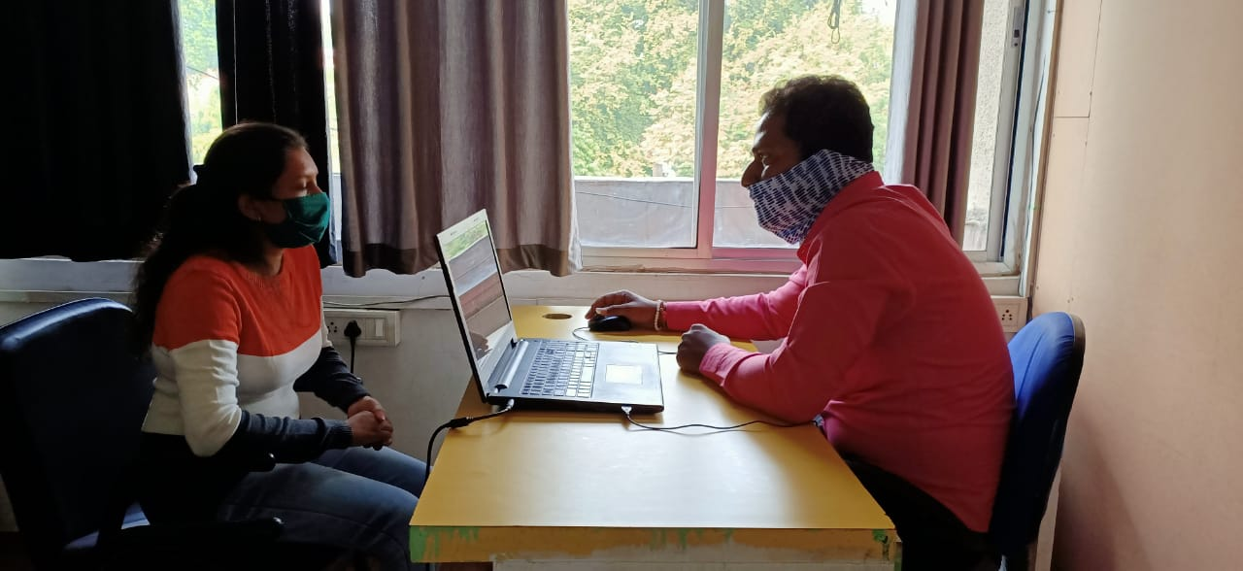

**NIDAN TECHNOLOGY PVT LTD**



**(DAY** **-NULM)**

**National Urban Livelihood Mission**

**Course: Accounts Assistant Using Tally**

Sayajigunj Center- Batch No: TN2438980153

**Practical Examination**

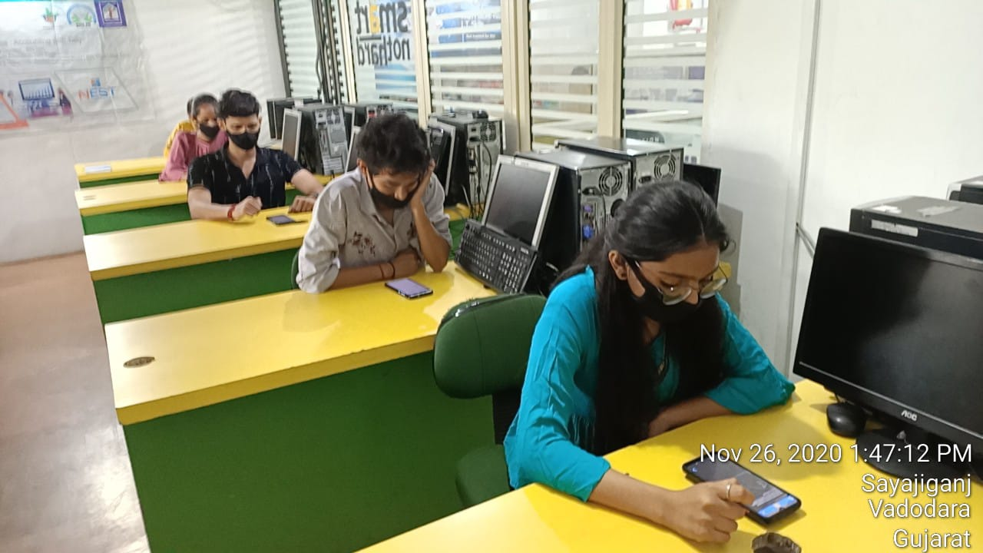 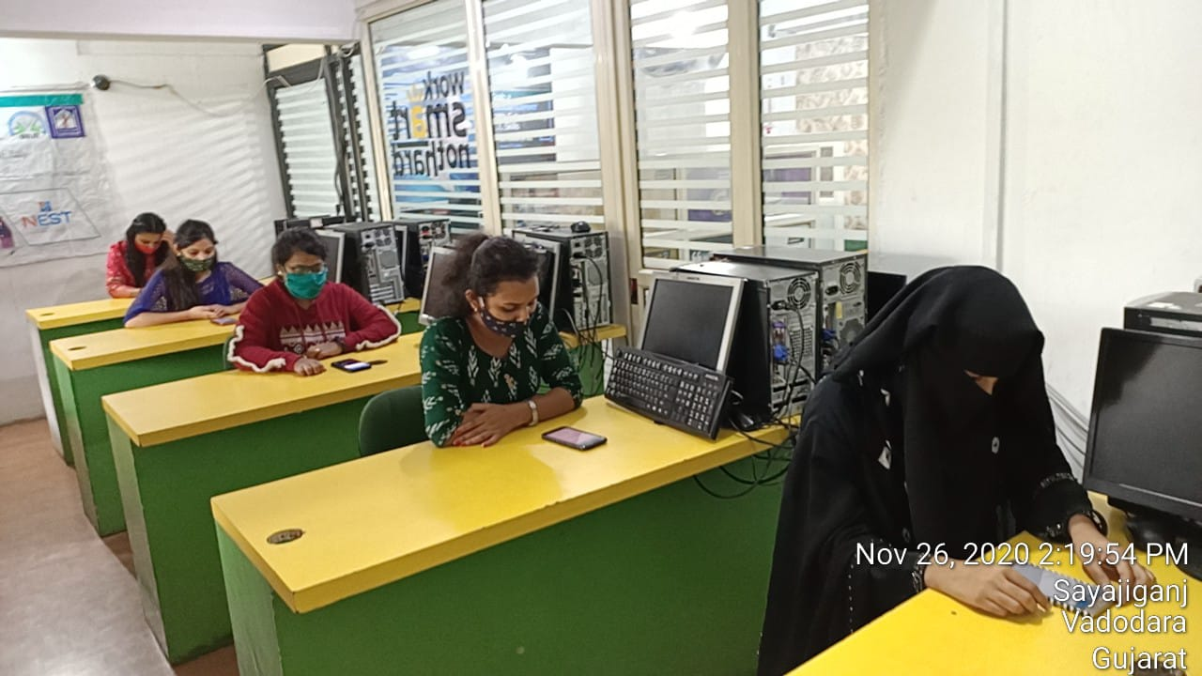

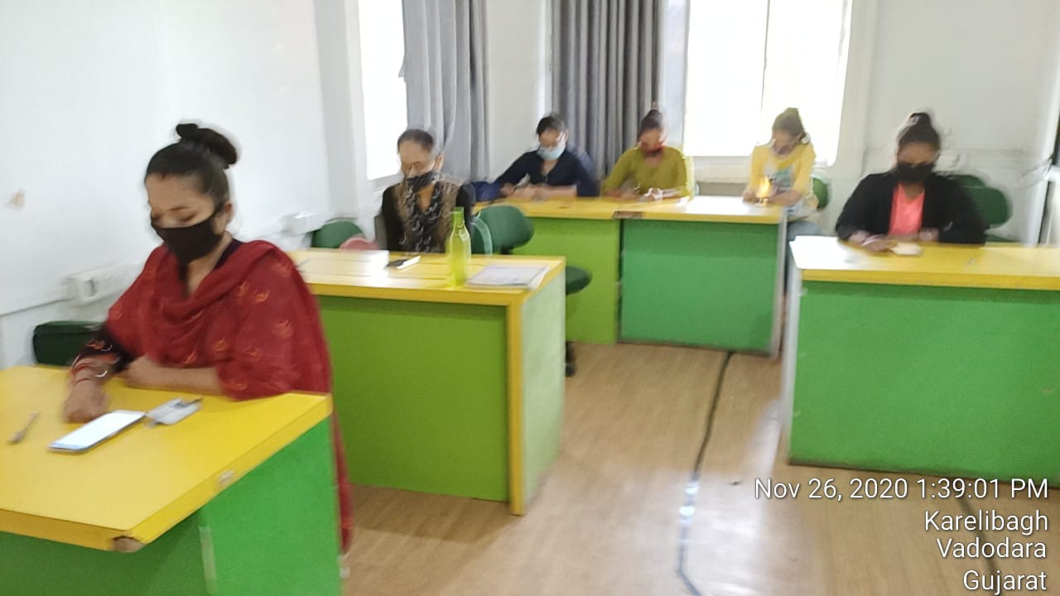 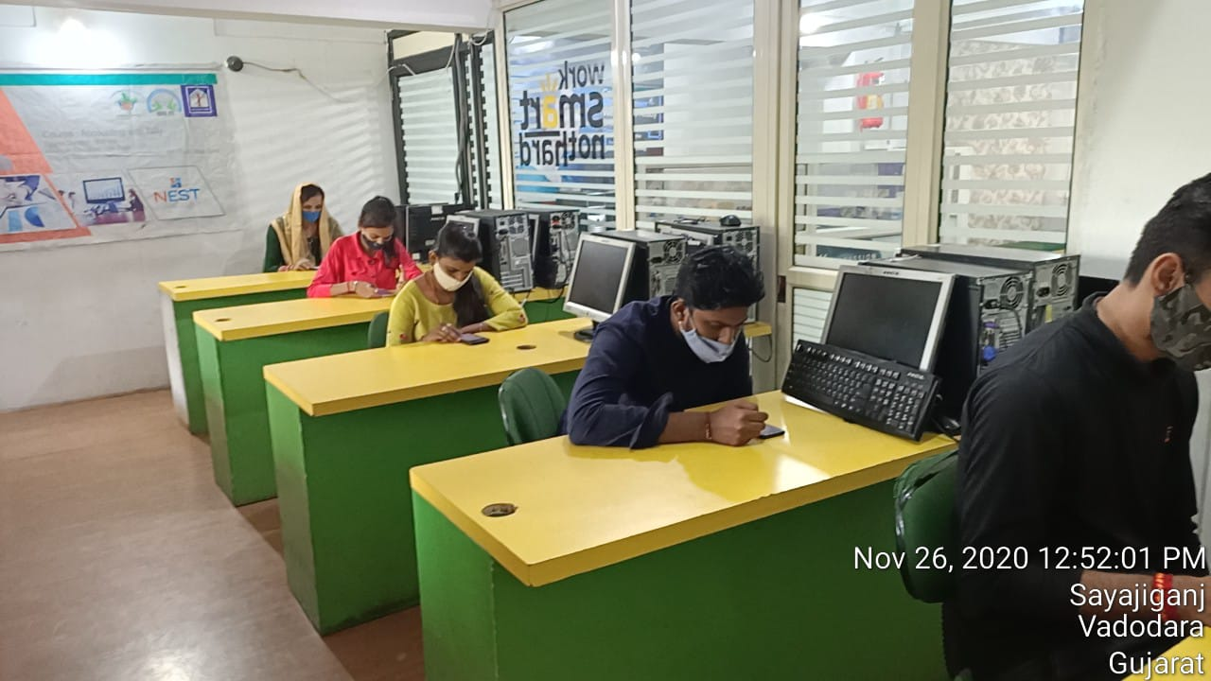

**NIDAN TECHNOLOGY PVT LTD**



**(DAY** **-NULM)**

**National Urban Livelihood Mission**

**Course: Accounts Assistant Using Tally**

Sayajigunj Center- Batch No: TN2438980153

**Attendance in Examination**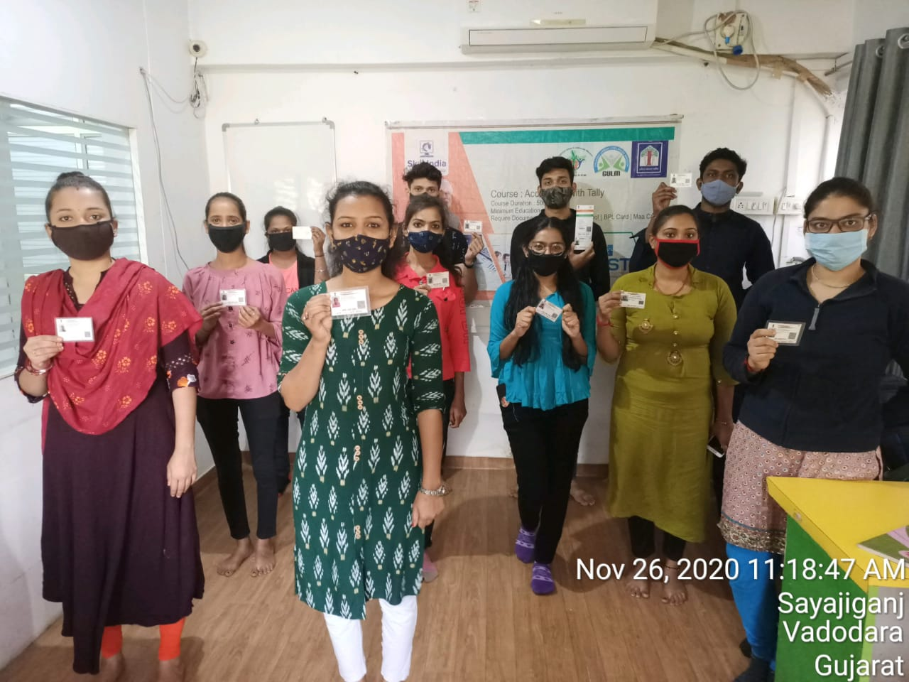

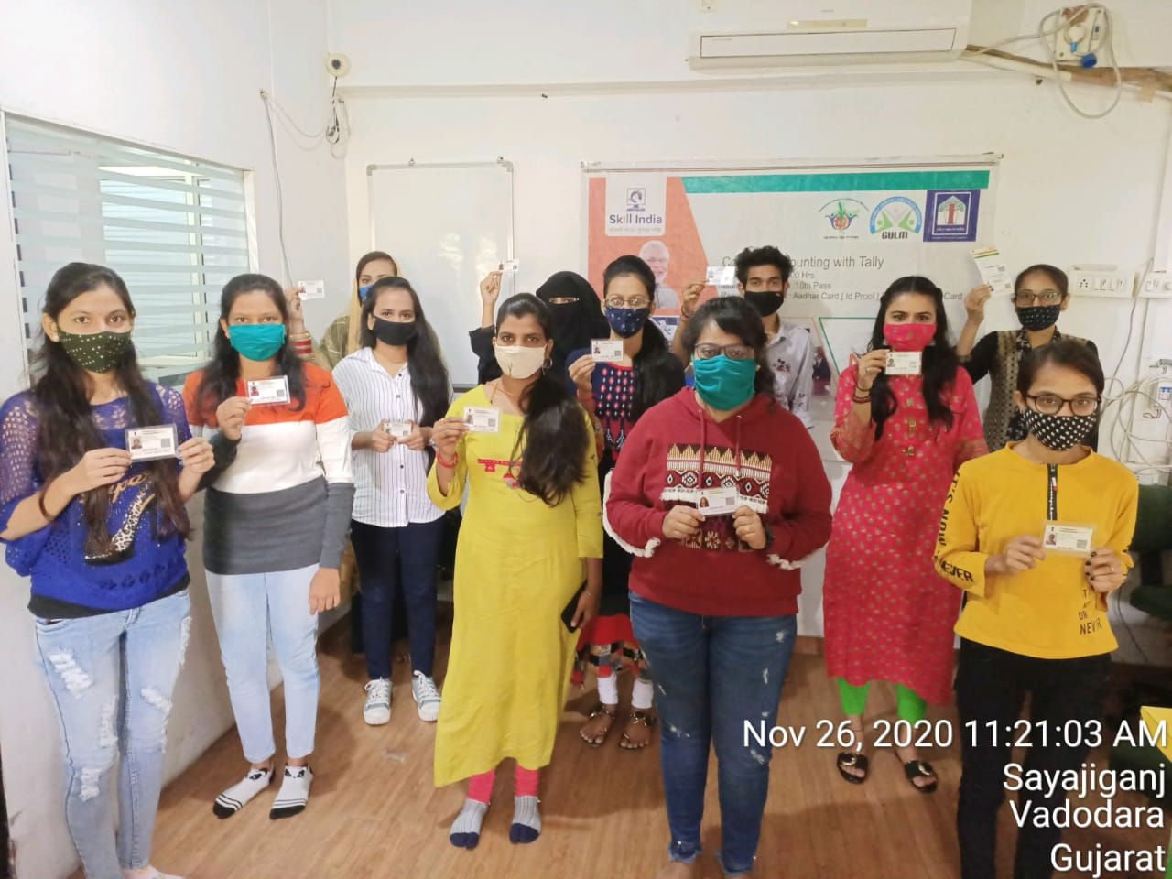

**NIDAN TECHNOLOGY PVT LTD**